**DSA-210**

**INTERMEDIARY REPORT**

**Car Tire Pressure – Temperature**

**Efe Utku Ural**

**33991**

**Project Overview**

This project looks into how driving and environmental factors relate to tire pressure in cars. Data gathered from March 13 to April 25, 2025, using a Tesla Model Y Standard Edition (single motor) is the main focus of the analysis. This study takes into account the effects of driving distance, altitude, car load, and outside temperature on tire pressure.

**Motivation**

As someone who drives daily to Sabancı University and other common destinations, I wanted to know how various outside factors would influence the tire pressure of my vehicle. This tracks tire condition and enhances vehicle maintenance plans.

**Dataframe**

**Timeframe:** March 13, 2025 – April 25, 2025  
**Vehicle:** Tesla Model Y Standard Edition (Single Motor)

**Data Columns:**

* Date
* Average Tire Pressure (PSI)
* Temperature (Celsius and Fahrenheit)
* Altitude (based on destination elevation)
* Car Load (kg) — includes personal weight (65kg), fixed cargo (30kg), and added weights from friends or family.
* Driving Distance (km)

**Identifying Correlations and Hypothesis Testing**

Pearson correlation coefficients were computed to understand how tire pressure changes with each factor.

|  |  |  |
| --- | --- | --- |
| **Variable** | **Pearson r** | **Interpretation** |
| Temperature (°C) | +0.851 | Strong positive correlation (validated) |
| Driving Distance (km) | +0.349 | Moderate positive correlation |
| Altitude (m) | -0.146 | Weak negative correlation |
| Car Load (kg) | +0.012 | Negligible correlation |

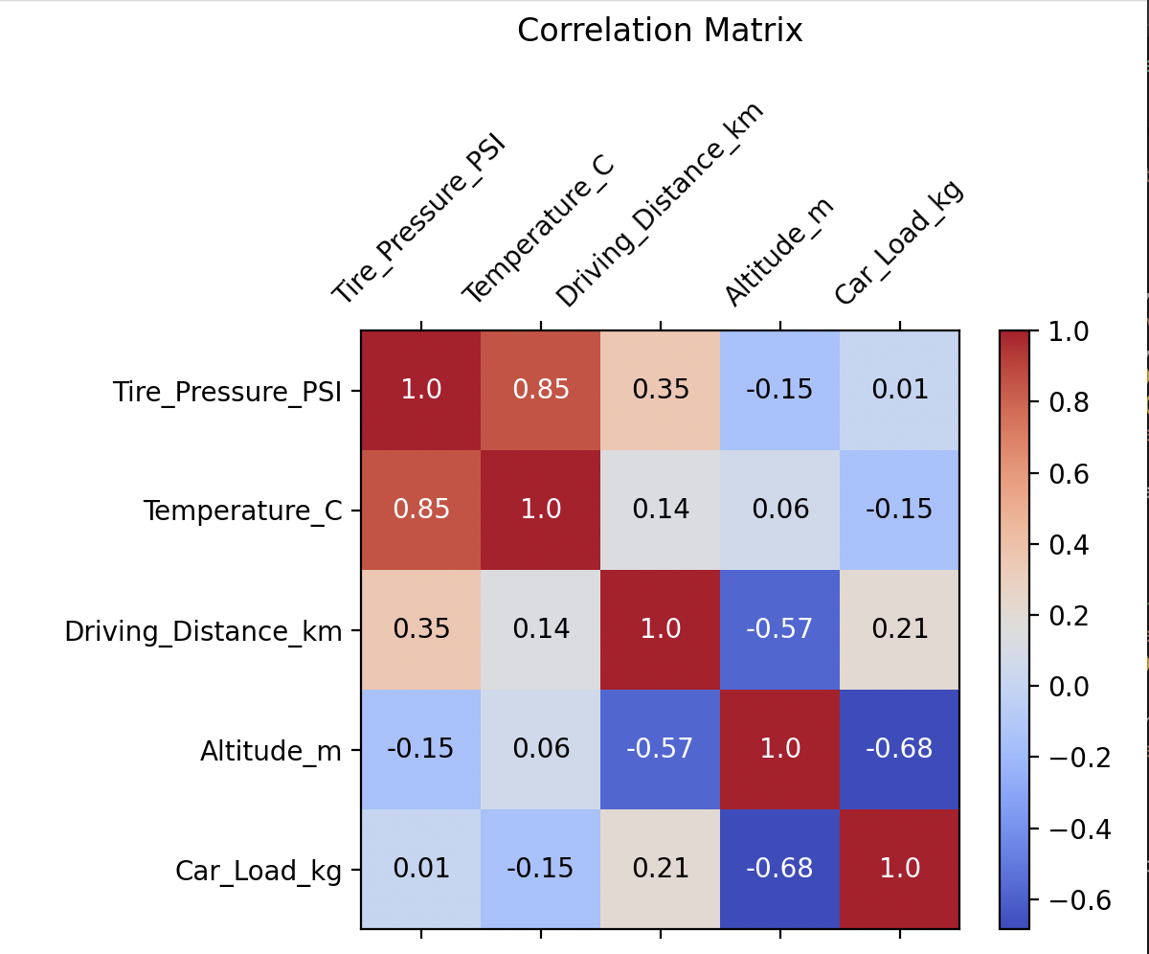

**Determined Hypotheses are as follows:**

**H1:** Tire pressure increases with outdoor temperature.  
**Result:** Supported (r = 0.851)

**H2:** Longer driving distance leads to increased tire pressure.  
**Result:** Moderately supported (r = 0.349)

**H3:** Heavier car load results in higher tire pressure.  
**Result:** Not supported (r = 0.012)

**H4:** Higher altitude has a significant effect on tire pressure.  
**Result:** Not supported (r = -0.146)

**Observations and Graphical Insights**

**Individual Graphics:**

Histogram of Tire Pressure: Shows the distribution of tire pressure values throughout the measurement period.

Boxplot of Tire Pressure: Indicates the median, quartiles, and outliers of tire pressure measurements.

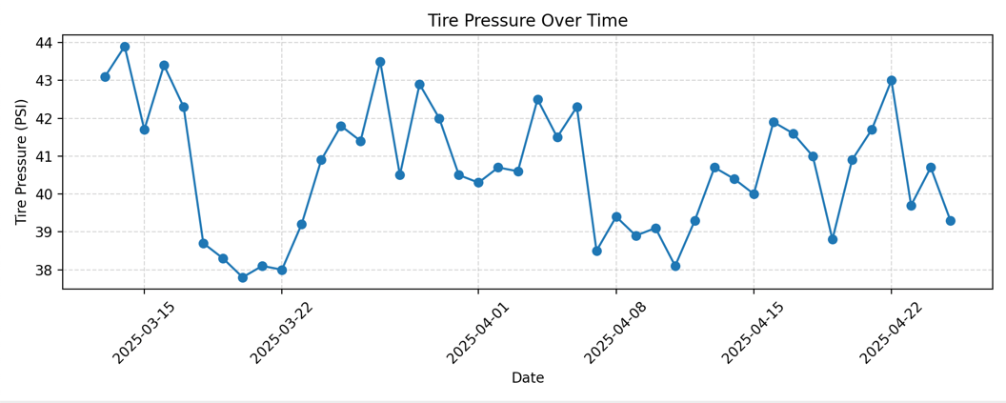

Line Plot: Tire Pressure Over Time: Illustrates daily changes and trends in tire pressure over the measurement period.

**Comparative Graphics:**

**Tire Pressure vs Temperature (**°**C)**

* **A graph with blue dots

  AI-generated content may be incorrect.**This scatter plot shows a strong positive linear relationship between temperature and tire pressure.  
  As the outside temperature increases, the tire pressure consistently rises.  
  This supports Hypothesis H1 and is confirmed by a Pearson correlation coefficient of **r = 0.851**.

**Tire Pressure vs Driving Distance (km)**

* This scatter plot shows a moderate positive relationship between driving distance and tire pressure.  
  Tire pressure tends to be higher when longer distances are driven, due to the heating of the tires during extended trips.  
  This finding moderately supports Hypothesis H2 with a Pearson correlation of **r = 0.349**.

**Tire Pressure vs Altitude (m)**

* This graph shows a weak negative relationship between altitude and tire pressure.  
  There is no clear visual pattern, and the slight downward slope indicates a very minimal decrease in pressure at higher altitudes.  
  The Pearson correlation of **r = -0.146** suggests that altitude has no significant effect in this specific dataset, thus not supporting Hypothesis H4.

**Tire Pressure vs. Car Load (kg)**

* A graph with blue dots

  AI-generated content may be incorrect.The scatter plot shows almost no visible trend between car load and tire pressure.  
  Tire pressure values remain fairly constant regardless of whether the car is heavily or lightly loaded.  
  This confirms the Pearson correlation result of **r = 0.012**, indicating negligible impact and rejecting Hypothesis H3.

**Conclusion**

* Strongly positively correlated, this project clearly shows that tire pressure fluctuations are mostly driven by temperature. Driving distance also has a small effect since longer distances tend to somewhat increase tire pressure by means of thermal expansion caused by tire heating. Conversely, although at first glance altitude and car load would influence tire pressure, in the recorded data their effects turned out to be negligible and statistically meaningless.
* All things considered, the results offer insightful information about how operational and environmental factors impact tire maintenance. Daily drivers like myself can better predict changes in tire pressure, maximize vehicle performance, improve safety, and encourage longer tire lifespan through proactive maintenance techniques by comprehending these relationships. The significance of routine tire inspections is emphasized by this study, especially after long-distance driving and during seasonal temperature fluctuations.